Adithya.J

230701013 CSE A

EXP NO:9 Bankers Deadlock Avoidance algorithms

PROGRAM

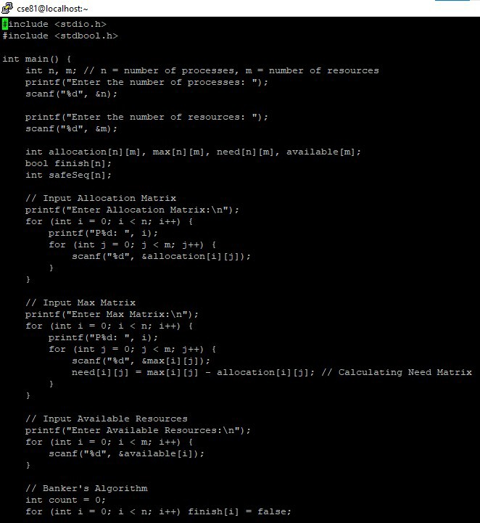

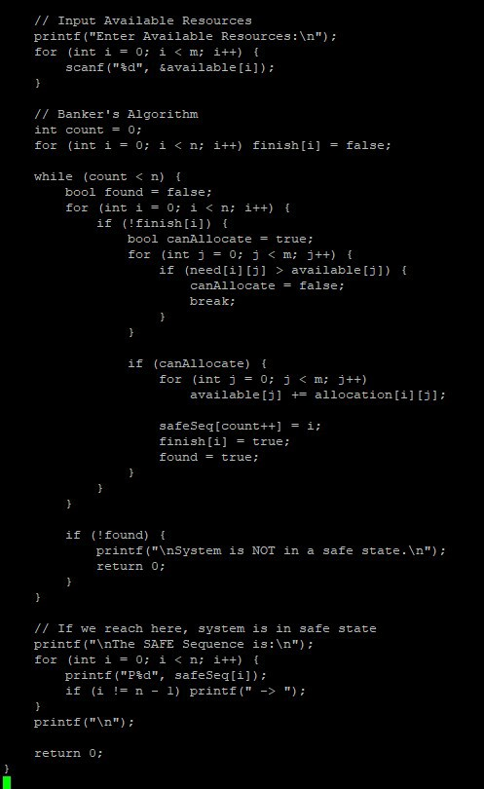

OUTPUT

